Pipelining
It is the process of dividing sequencial process and parallelizing it in a processor.

Parallel Processing:
Flyn’s classification of parallel processing:
- Single instruction stream single data stream
- Single instruction stream multiple data stream
- Multiple instruction stream single data stream
- Multiple instruction stream muliple data stream

Single instruction stream single data stream
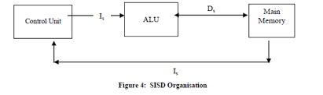

Single instruction stream multiple data stream
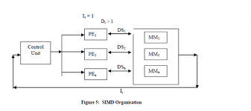

Multiple instruction stream single data stream
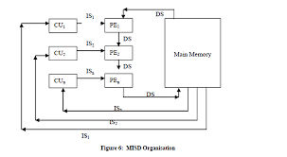

Multiple instruction stream muliple data stream
